Fresh sample
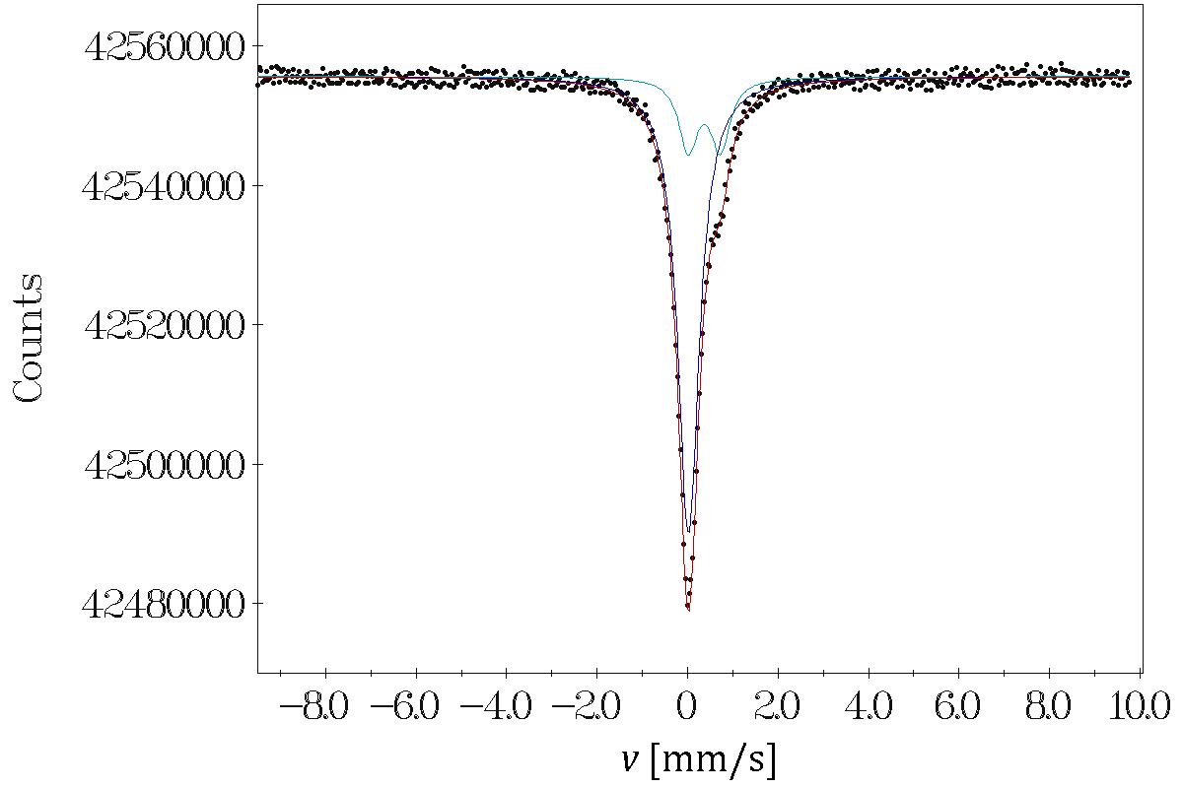
SINGLET (1),78.6 %
AMPLITUDE,59726.2915
ISOMER SHIFT,-0.0018
LINE WIDTH,0.5793
DOUBLET (1),21.4 %
AMPLITUDE,8115.6111
ISOMER SHIFT,0.3500
Q. SPLITTING,0.7100
LINE WIDTH,0.5087

Air 30 days
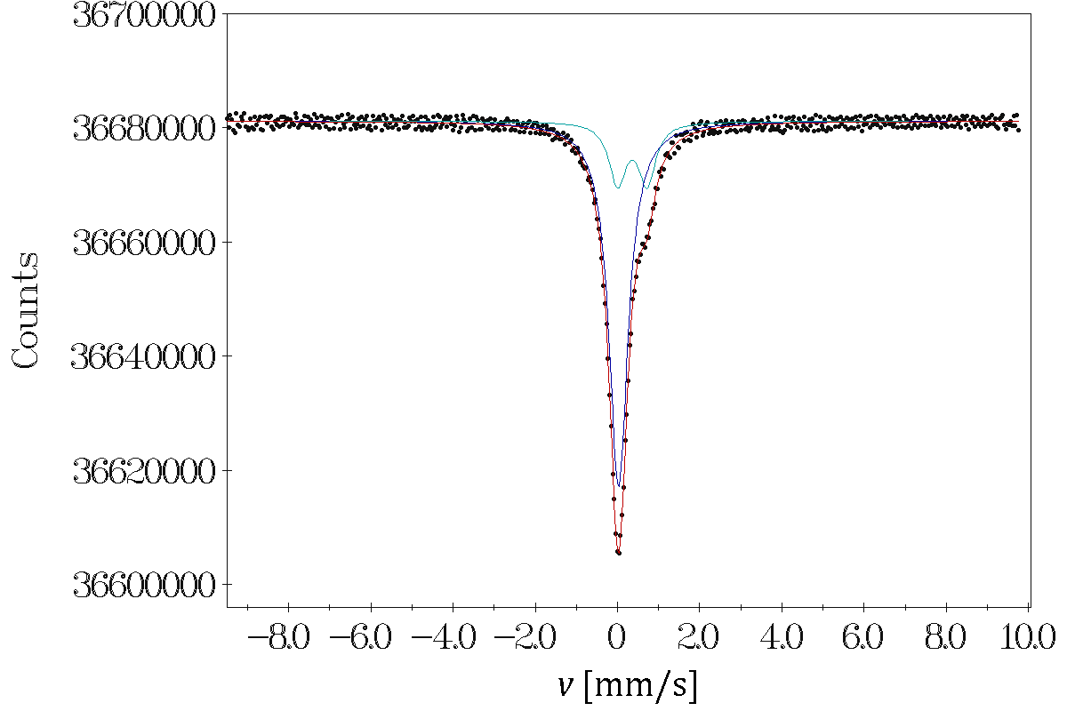
SINGLET (1),77.1 %
AMPLITUDE,56334.2081
ISOMER SHIFT,0.0047
LINE WIDTH,0.5600
DOUBLET (1),22.9 %
AMPLITUDE,8346.6417
ISOMER SHIFT,0.3400
Q. SPLITTING,0.7200
LINE WIDTH,0.4990

Physiological solution 30 days
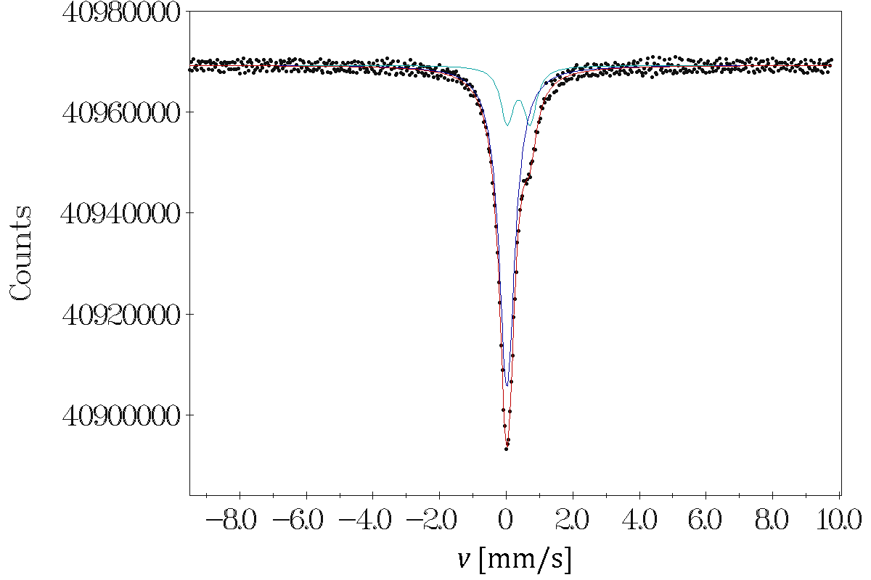
SINGLET (1),78.3 %
AMPLITUDE,57792.5086
ISOMER SHIFT,-0.0022
LINE WIDTH,0.5763
DOUBLET (1),21.7 %
AMPLITUDE,8027.4741
ISOMER SHIFT,0.3500
Q. SPLITTING,0.6900
LINE WIDTH,0.4701

